Eastern Region Khobar

Pcs For Easton Region Khobar

1-

IP: 192.170.1.4

F0/2

F0

default gateway :192.170.1.7

2-

IP: 192.170.1.5

F0/3

F0

default gateway :192.170.1.7

Laptop For Easton Region Khobar

IP: 192.170.1.6

F0/4

F0

default gateway :192.170.1.7

Printer For Easton Region Khobar

IP:192.170.1.8

Server For Easton Region Khobar

IP:192.170.1.10

Gateway For Easton Region Khobar

HomeGateway02

192.168.25.1

Router (1841) For Easton Region Khobar

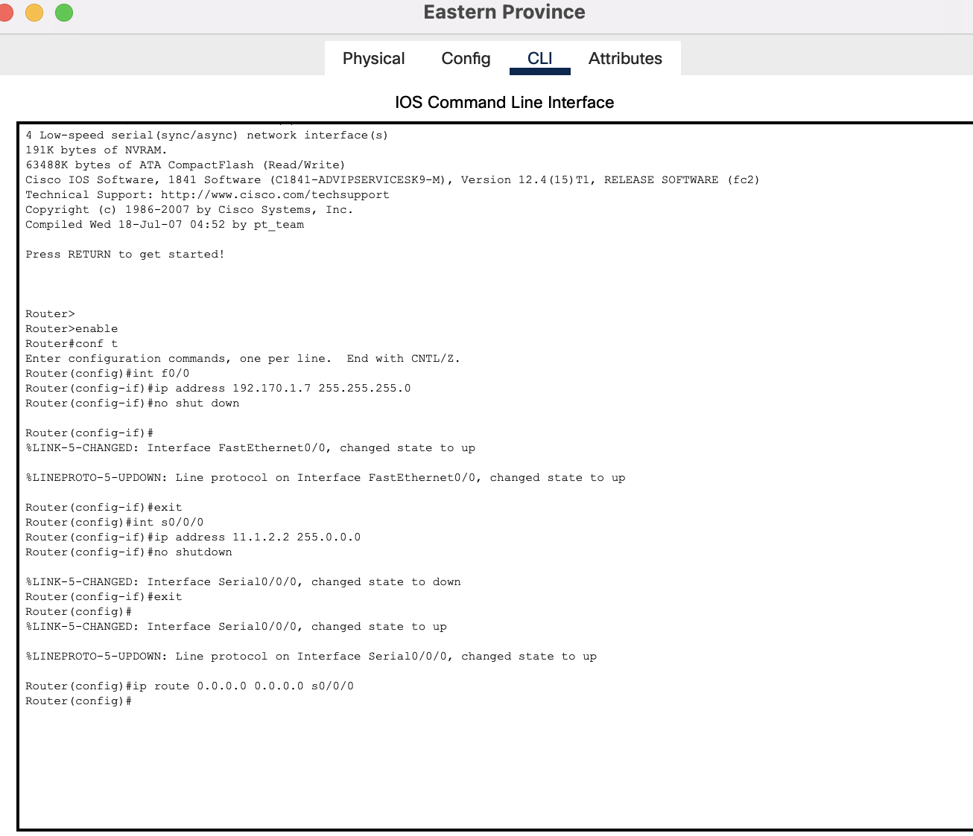

Router (2811) For Easton Region Khobar

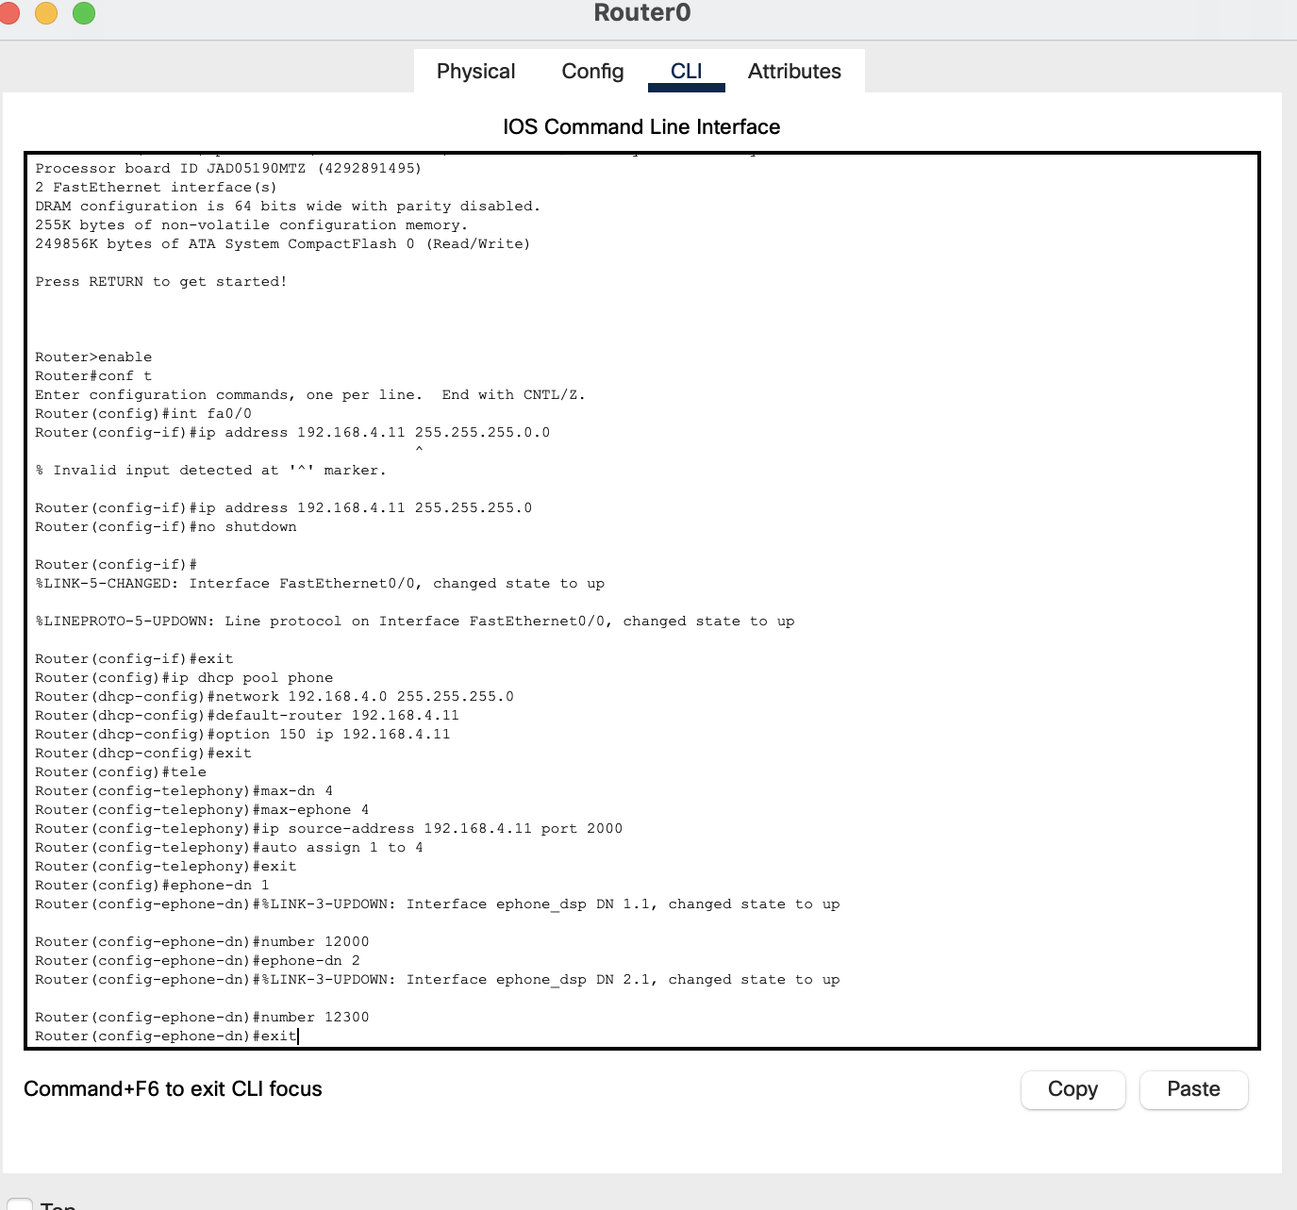

Switch (2960 For Easton Region Khobar

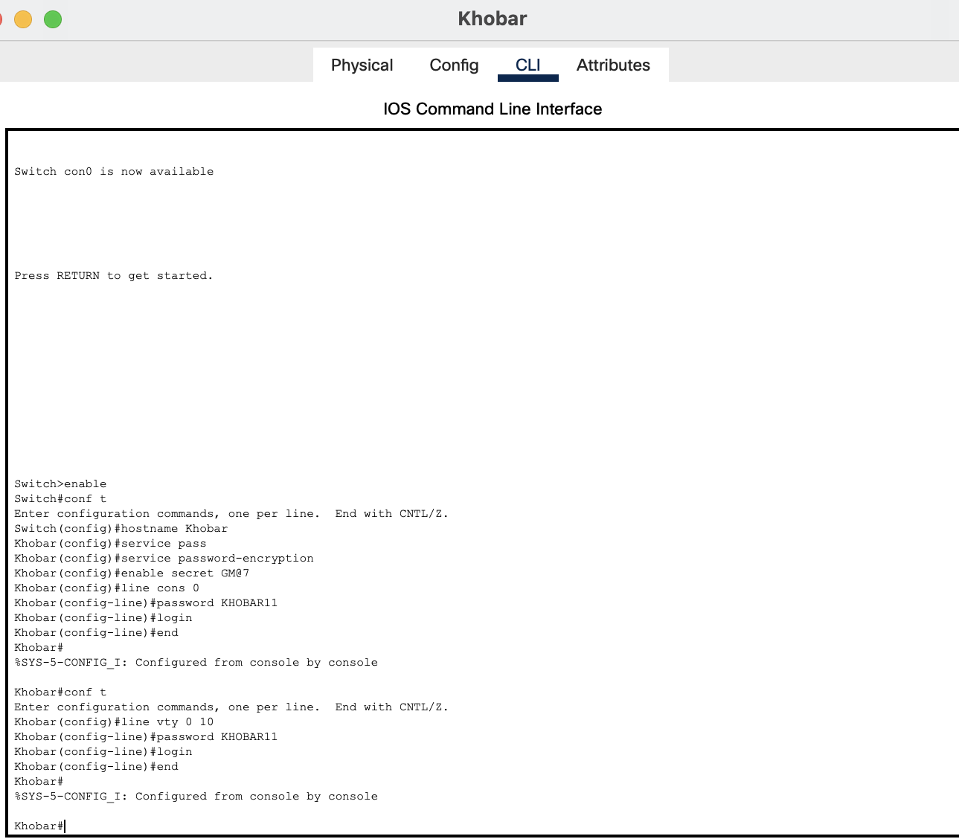

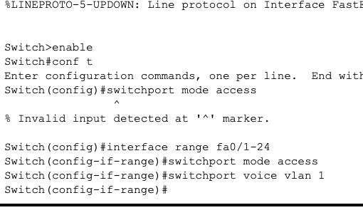

Server For Easton Region Khobar

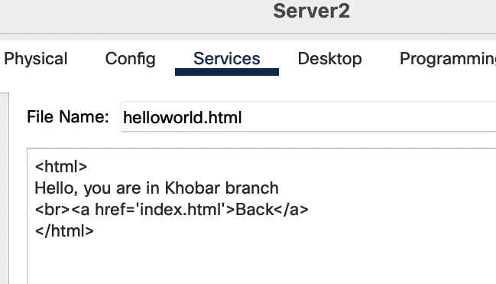

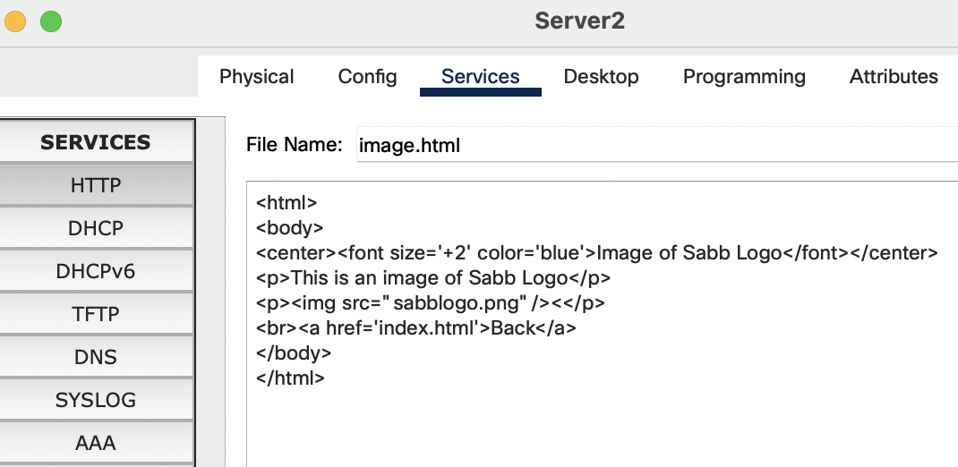

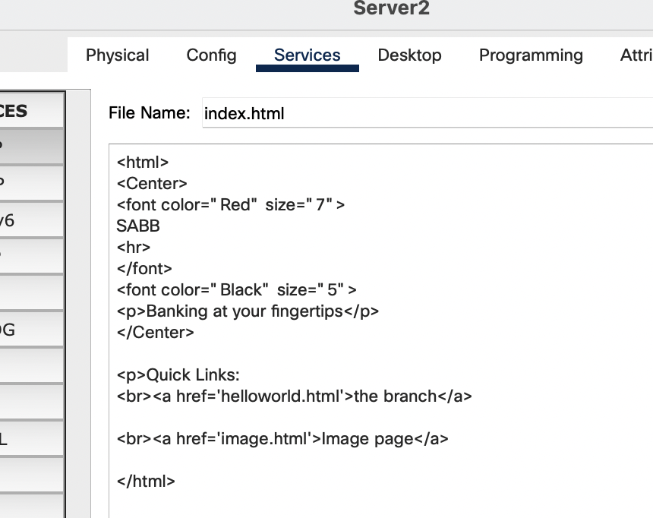

Fire Detectot (Python)

